**POPSICLE BRIDGE COMPETITION**

**(CABLE STAYED)**

**WHAT IS IT?** Teams of students will construct bridges in advance of the competition using only Popsicle sticks (ice-cream sticks), glue (fevicol), paper and cotton threads. Bridges will be judged on aesthetics and originality of design, presentation, ultimate load carrying capacity according to formula given below. Teams will consist of maximum 4 students. Teams will have the opportunity to prepare the bridges to be judged on presentation.

1. **Objective**

To build a cantilever cable stayed bridge within given specifications. It must be constructed of approved materials.

1. **Apparatus**

1. **Building Materials:** 
   1. Popsicle sticks (For making the whole beam)
   2. Cotton threads (For making cables)
   3. Glue (For joining the popsicle sticks)
   4. Paper (For reinforcing joints)

1. **Dimensions**:
   1. Min Span Length - 500 mm
   2. Min Column height - 300mm
   3. Min Span Width - 100 mm
   4. Min space between two parallel sticks - 50mm
   5. Max 3 cables can be attached on each side.
   6. The column should be compulsorily square in dimensions.
   7. The height of column above the span should be at least 100mm.
   8. Column span should be in one plane only.
   9. Maximum 4 sticks can be joined together.

To clear all the doubts refer the following diagram : (NOTE: This fig. is just a demo.)

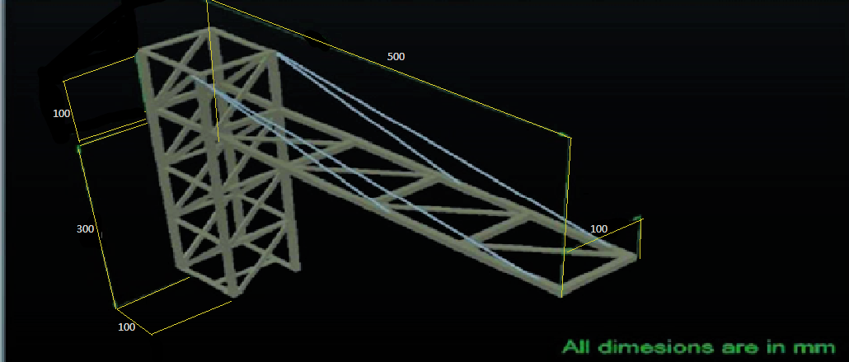

**C. The Competition:**

1. Maximum 4 members are allowed in one team.
2. Teams must submit their bridge 1/2 hour before the competition for inspection.
3. Inspection team will test that the construction rules were followed.
4. Once the bridge is in position, loads will be applied uniformly on the deck starting from the free end of the cantilever.
5. Beams will then be subjected to loading. Bridge failure will be considered the point at which the bridge breaks.

**D. Judging and Scoring:**

1. Final Score A = 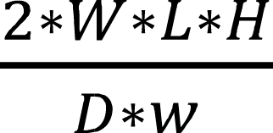

Where, W = Weight taken by structure (in gram)

H = Height of column from bottom to the beam of structure (in cm)

L = Length of span (in cm)

D = Deflection (in cm)

w = Weight of the structure (in gram)

1. In case two teams have same score then the team having higher value of 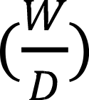 will have preference over the other team.
2. The excessive use of materials at joints may lead to deduction of points in overall score.
3. The bridge with the highest score wins the event.
4. Violation of any of the above stated rules may lead to disqualification or deduction in score.
5. Prize will be given only if there are minimum 5 participants.

NOTE: Support at the base of the column will be provided. So, make the column uniform in dimensions.

**FOR QUERIES CONTACT:**

**CO-ORDINATORS:**

FATEH SINGH

MOBILE NO. 9079916657

# EMAIL: fscharan8991@gmail.com

ANUJ VERMA

MOBILE NO. 8849162357

# EMAIL: ajverma499@gmail.com

**TECHNICAL HEAD:**

JENISH PATEL

MOBILE NO. 7984535537

# 